Kingdom of Saudi Arabia  Ibn Sina National College for  Medical Studies | 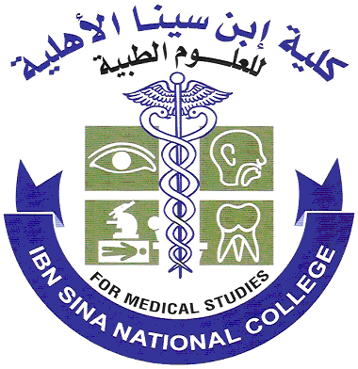
6th.MBBS-OBS-GYN-Qz-I–MALES
2025-2026
(8:45 - 9:30) AM
Subject Name: Obs-Gyn-Qz-I Quiz-I
Date: 3 / 09 / 2025 Lab No: 106
Ground Floor
Ser.  No | Student Name | Ac. No. | Signature
1 |  | 1811045
2 |  | 1910021
3 |  | 1910103
4 |  | 1910152
5 |  | 1910157
6 |  | 1910202
7 |  | 1910309
8 |  | 2010115
9 |  | 2010129
10 |  | 2010153
11 |  | 2010163
12 |  | 2010167
13 |  | 2010188
14 |  | 2010237
15 |  | 2010245
16 |  | 2010280
17 |  | 2010292
18 |  | 2010340
19 |  | 2010354
20 |  | 2010368
21 |  | 2010393
22 |  | 2010399
23 |  | 2110015
24 |  | 2110028
25 |  | 2110032
26 |  | 2110034
27 |  | 2110038
28 |  | 2110050
29 |  | 2110071
30 |  | 2110072
31 |  | 2110176
32 |  | 2110189
33 |  | 2110192
34 |  | 2110193
35 |  | 2110454

Name of the invigilator | Signature of Invigilators
1. |  | No.of Absent =
2. |  | Total Present=
3. |  | Total=

Kingdom of Saudi Arabia
Ibn Sina National College for
Medical Studies

