Kingdom of Saudi Arabia
Ibn Sina National College for Medical Studies in Jeddah

Syllabus for
Clinical Fixed Prosthodontics II
(PROS 532)
(2 Credit Hours)

Year 6th BDS

1434 – 1435 H
2013 – 2014 G
Welcome to Clinical Fixed Prosthodontics II Course!
Dear Student,
I would like to welcome you to the “Clinical Fixed Prosthodontics II” Course.
This study guide will show you details of necessary knowledge related to the subject. This course is the final fixed prosthodontic course and is given during the sixth year. It is a part of comprehensive clinical care course. It provides students with an opportunity to integrate all basic and advanced fixed prosthodontic concepts learnt to date in a clinical setup.
This course consists of mainly the clinical sessions wherein the learner is expected to diagnose clinical condition, formulate the treatment plan and finally execute the treatment by various fixed prosthodontic procedures under the supervision of faculty.
There are very interesting and brainstorming interactive learning sessions which will give you the opportunity to discuss related topics in more details helping you in acquiring required knowledge for the successful management of various clinical situations. In these sessions you will be assessed about patient management skills through question and answer sessions, the importance of time management and infection control is stressed upon.
The reference materials include text books, journal articles and web based references will help you find more information, and the learners are encouraged and directed for self learning and self assessment strategies.
As a coordinator, I will be there to receive your feedback and comments and to try to resolve any difficulties during the implementation of the course. Please do not hesitate to contact me at any time if you need any help. The other staff members teaching the course are also available for any help you may need in case you have subject-related enquiries.
I wish you an enjoyable and successful experience with the Clinical Fixed Prosthodontics II Course.

The Coordinator

Contents
Curriculum Map
introduction to the Course
General Objectives of the Course
Course Contents
Coordinator and Teachers of the Course
Learning Resources
Student Assessment
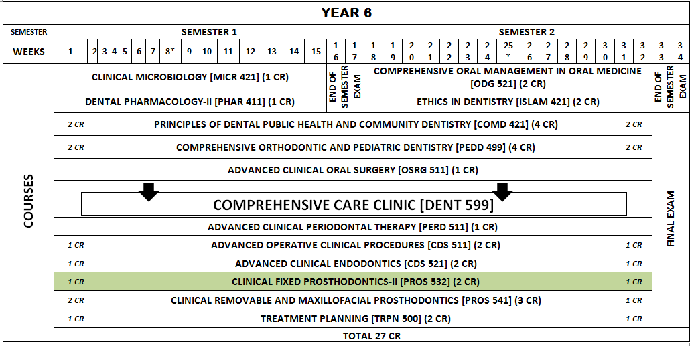
Curriculum Map

Introduction to the Course
Welcome to the Clinical Fixed Prosthodontics II course. My objective in this course is to help you understand the formulation of the treatment plan and to carry out treatment procedures related to fixed prosthodontics as a part of comprehensive clinical care program. In this course there is an integration of the knowledge and skills learned to date in the field of clinical fixed and removable prosthodontics to treat the patients to restore esthetics, function and comfort.
General Objectives of the Course
Upon completion of the course, students should be able to:
- Select cases, understand, and perform the procedures which lead to a clinically sound fixed prosthodontic therapy.
- Bring together fixed and removable prosthodontic concepts learned to date for the purpose of integrated prosthodontic patient care.

Course Contents
Lectures
N. | Title | Subject | Teacher | Page
L 1 | Diagnosis and Treatment Planning in Fixed Prosthodontics | Clinical Fixed prosthodontics | Dr. Girish Kubasad Dr Maher Babsail
L 2 | Metal Ceramic Restorations | Clinical Fixed prosthodontics | Dr. Girish Kubasad Dr Maher Babsail
L 3 | Restoration of Endodontically Treated Teeth | Clinical Fixed prosthodontics | Dr. Girish Kubasad Dr Maher Babsail
L 4 | All Ceramic Restorations | Clinical Fixed prosthodontics | Dr. Girish Kubasad Dr Maher Babsail
Clinical Sessions
N. | Title | Subject | Teacher | Page
C 1 | Diagnosis and Initial Approval | Clinical fixed prosthodontics II | Dr Girish Kubasad, Dr Maher, Dr Hemanthkumar,, Dr Waleed
C 2 | Diagnostic Impressions, Diagnostic Casts Mounting, Obtaining Radiographs, Photographs | Clinical Fixed prosthodontics II | Dr Girish Kubasad, Dr Maher, Dr Hemanthkumar,, Dr Waleed
C 3 | Definitive Treatment Planning and agreement with faculty | Clinical Fixed prosthodontics II | Dr Girish Kubasad, Dr Maher, Dr Hemanthkumar,, Dr Waleed
C 4 | Tooth preparations, impression making and cementation of provisional restoration. | Clinical Fixed prosthodontics II | Dr Girish Kubasad, Dr Maher, Dr Hemanthkumar, Dr Waleed
C 5 | Try in evaluation of framework, shade selection | Clinical Fixed prosthodontics II | Dr Girish Kubasad, Dr Maher, Dr Hemanthkumar,, Dr Waleed
C 6 | Evaluation of definitive restoration and cementation | Clinical Fixed prosthodontics II | Dr Girish Kubasad, Dr Maher, Dr Hemanthkumar,, Dr Waleed

Coordinator and Teachers of the Module
Nº. | Name | Department | Ext # | Room # | E-mail | Office Hours
Coordinator:
1 | Dr. Girish Kubasad | Dept of Oral and maxillofacialRehabilitation | 364 | 364 | girishkubasad@yahoo.com | Sunday: 9-12noon  Tuesday: 1-4 pm
Teachers:
1 | Dr. Maher Babsail | Dept of Oral and maxillofacial Rehabilitation | 364 | 364 | maher_babsail@hotmail.com
2 | Dr. Hemanth kumar | Dept of Oral and maxillofacial Rehabilitation | 364 | 364 | drphemanth@gmail.com
3 | Dr. Waleed | Dept of Oral and maxillofacial Rehabilitation | 364 | 364 | dr. waleed.sunallah @hotmail.com

Learning Resources
List of required book:
- Contemporary Fixed prosthodontics, 4th Edn, Rosensteil, Mosby-Elseveir, 2012.
- Fundamentals of Fixed prosthodontics, 3rd Edn. Shillingburg, Quintessence publishing.

Journals:
- Journal of prosthetic dentistry.
- Dentistry Today.
- Journal of prosthodontics.
- International journal of Prosthodontics.

Student Assessment
- Formative Assessment:
Questions and answers during active learning sessions.
- Summative Assessment:
Method | Type of questions | Timing
Midyear Examination | MCQs and essays in the form of short essays | 16th and 17th weeks
Final writing exam | MCQs and essays in the form of short essays | 33rd and 34th weeks
Minimum Procedural Experience (MPE) |  | Throughout the year
Final Clinical Competency test |  | ^{th} week
Case presentation

